SMART FIRE DETECTION SYSTEM USING IOT TECHNOLOGY

# PAMANJI THANOOJ, U.SAI KIRAN REDDY, VAMSHI REDDY

ECE,VIT CHENNAI

1. ***Abstract*** :

The increasing frequency of fire incidents in residential and commercial buildings necessitates the development of advanced fire detection and alarm systems to ensure prompt and efficient response. In this research paper, we propose a smart fire alarm system utilizing Arduino microcontroller, a buzzer, and a GSM modem to enhance fire safety measures.The main objective of this study is to design an intelligent fire alarm system that integrates real-time fire detection, alert mechanisms, and remote monitoring capabilities. The Arduino microcontroller serves as the central processing unit, responsible for receiving input from various sensors, processing the data, and triggering appropriate actions.

The fire detection mechanism employs a combination of temperature and smoke sensors to accurately identify the presence of fire. When a potential fire hazard is detected, the Arduino microcontroller activates the buzzer, producing a loud alarm to alert occupants and nearby individuals. Additionally, the system is equipped with a GSM modem, enabling it to send instant SMS notifications to designated emergency contacts, such as homeowners or fire departments.

To ensure the system's reliability and responsiveness, extensive testing and validation procedures were conducted. The system's performance was evaluated in different fire scenarios to assess its accuracy in detecting fires and the efficiency of its alert mechanisms. Furthermore, the remote monitoring feature was assessed to determine its effectiveness in providing real-time updates to authorized personnel.

The results of the study demonstrate that the proposed smart fire alarm system effectively detects fires in a timely manner and promptly notifies relevant parties. The integration of Arduino, buzzer, and GSM modem provides a cost-effective and scalable solution for enhancing fire safety in both residential and commercial settings.

The research presented in this paper contributes to the ongoing efforts in developing intelligent fire alarm systems by combining emerging technologies with traditional fire detection methods. The findings offer valuable insights into the design, implementation, and performance evaluation of such systems, paving the way for further advancements in fire safety technology.

1. **INTRODUCTION:**

Fire accidents pose a significant threat to lives and property, emphasizing the need for robust and efficient fire detection and alert systems. Traditional fire alarm systems have been widely employed, but they often lack advanced features such as real-time

notifications and remote monitoring. To overcome these limitations, the integration of emerging technologies, such as Arduino

microcontrollers, buzzers, and GSM modems, provides a promising solution for developing a smart fire alarm system.The objective of this research paper is to present a novel approach to fire detection and alerting using the Arduino platform in conjunction with a buzzer and GSM modem. By leveraging the capabilities of these components, the proposed system enhances traditional fire alarms with advanced functionalities, including real-time notifications via SMS and remote monitoring capabilities. The Arduino

microcontroller serves as the central processing unit of the system, responsible for collecting sensor data, analyzing it, and triggering appropriate actions when a fire event is detected. Multiple fire sensors, such as smoke detectors and temperature sensors, are

strategically placed to ensure comprehensive coverage within the monitored area. These sensors continuously measure

environmental parameters and relay the data to the Arduino for processing.Upon detecting abnormal fire-related conditions, the Arduino activates the buzzer to provide an audible warning within the vicinity. This immediate auditory alert ensures that

individuals in the vicinity are promptly made aware of the potential fire hazard. Additionally, the system integrates a GSM modem, enabling it to send real-time notifications to designated individuals or emergency services via SMS. These notifications include vital information such as the location of the fire and relevant sensor data, enabling swift response and effective mitigation of the fire

incident.

Furthermore, the system supports remote monitoring, allowing authorized users to access and monitor the fire alarm system from

any location with an internet connection. This feature empowers property owners, building managers, and emergency responders to have real-time visibility into the fire alarm status, enabling quick decision-making and appropriate action in emergency scenarios.In this research paper, we will discuss the design, implementation, and evaluation of the smart fire alarm system utilizing Arduino, buzzer, and GSM modem components. We will explore the hardware setup, software algorithms, and communication protocols

employed to enable seamless integration and efficient functioning of the system. Additionally, we will present experimental results,

including performance metrics such as detection accuracy, response time, and reliability, to assess the effectiveness and reliability of the proposed smart fire alarm system.

The outcomes of this research will contribute to the advancement of fire safety technology, bridging the gap between conventional fire alarm systems and intelligent, connected systems. The proposed system's enhanced features, including real-time notifications

and remote monitoring capabilities, have the potential to significantly improve response times, minimize property damage, and save lives in fire-related emergencies.

1. **Keywords**:

smart fire alarm system, Arduino, buzzer, GSM modem, fire detection, real-time notifications, remote monitoring, safety technology.

# System architechture (algorithm):

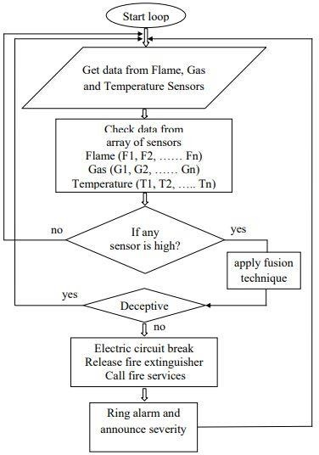

1. **METHODOLOGY:**

Components needed:

Arduino board (e.g., Arduino Uno) Fire sensor module

Buzzer

GSM modem (e.g., SIM800L)

SIM card with an active plan for SMS messaging

Connect the fire sensor module to the Arduino board. Typically, fire sensors have three pins: VCC, GND, and OUT. Connect VCC to 5V on the Arduino, GND to GND, and OUT to a digital input pin (e.g., pin 2).

Connect the buzzer to the Arduino. Connect one pin of the buzzer to a digital output pin (e.g., pin 3) and the other pin to GND.

Connect the GSM modem to the Arduino. Make the following connections:

GSM modem RX to Arduino TX (digital pin 10) GSM modem TX to Arduino RX (digital pin 11) GSM modem VCC to Arduino 5V

GSM modem GND to Arduino GND Open a new sketch in the Arduino IDE. Write the code for the fire alarm system

Connect your Arduino board to your computer using a USB cable.

Select the correct board and port in the Arduino IDE by going to "Tools" -> "Board" and selecting your Arduino board model and then selecting the appropriate port.

Click on the "Upload" button in the Arduino IDE to upload the code to your Arduino board. Power on the Arduino board.

When the fire sensor detects a fire, the buzzer will sound, and the GSM modem will send an SMS to the specified recipient (phone number).

Make sure you have inserted a SIM card with an active plan into the GSM modem.

# EXPERIMENTAL RESULTS:

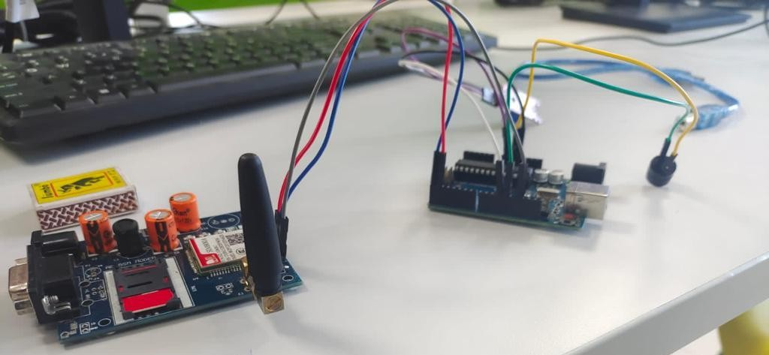

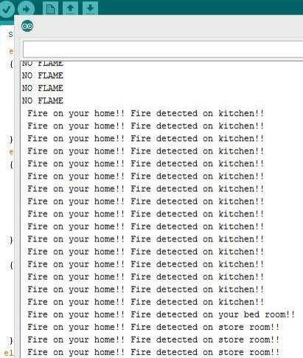

**It also gives mobile call from the sim which is present in gsmmodem**

# Conclusion:

This project aims toaims to provide an effective and efficient solution for fire detection and alerting. By combining Arduino's programmability, a buzzer for local notification, and a GSM modem for remote communication, this system offers enhanced safety measures.The Arduino acts as the brain of the system, processing inputs from various fire

detection sensors such as temperature or smoke sensors. When a fire hazard is detected, the Arduino triggers the buzzer to sound an audible alarm in the immediate vicinity, alerting occupants of the building. Simultaneously, the Arduino

communicates with the GSM modem to send a text message or make a call to pre-defined emergency contacts, notifying them about the fire emergency.The integration of the GSM modem allows for real-time communication, enabling

emergency responders or building administrators to receive immediate notifications regardless of their location. This feature ensures that timely actions can be taken to minimize the potential damage caused by the fire.

Overall, the smart fire alarm system with Arduino, buzzer, and GSM modem combines hardware and wireless

communication technologies to enhance fire safety measures. By providing both local and remote alerts, it significantly improves the chances of timely response and reduces the risk of property damage and harm to occupants.

# REFERNCES:

1. Bu, F. and Gharajeh, M. S., “Intelligent and vision-based fire detection systems: A survey,” Image and Vision Computing, vol. 91, 2019, Art. no. 103803.
2. Saeed F., Paul, A., Rehman, A., Hong, W. H., Seo, H., “IoT-based intelligent modeling of smart home environment for fire prevention and safety,” Journal of Sensor and Actuator Networks, vol. 7, no. 1, 2018, Art. no. 11.
3. Saeed, F., Paul, A., Karthigaikumar, P. and Nayyar, A., “Convolutional neural network based early fire detection,” Multimedia Tools and Applications, vol. 79, pp. 9083-9099, 2020.
4. Shokouhi, M., Nasiriani, K., Khankeh, H., Fallahzadeh, H. and Khorasani-Zavareh, D., “Exploring barriers and challenges in protecting residential fire-related injuries: a qualitative study,” Journal of injury and violence research, vol. 11, no. 1, pp. 81-92, 2019.
5. Kodur, V., Kumar, P. and Rafi, M. M., “Fire hazard in buildings: review, assessment and strategies for improving fire safety,” PSU Research Review, vol. 4, no. 1, pp. 1-23, 2019.
6. Salhi, L., Silverston, T., Yamazaki, T. and Miyoshi, T., “Early Detection System for Gas Leakage and Fire in Smart Home Using Machine Learning,” 2019 IEEE International Conference on Consumer Electronics (ICCE), Las Vegas, NV, USA, 2019, pp. 1-6.
7. Zhang, B., Sun, L., Song, Y., Shao, W., Guo, Y. and Yuan, F., “DeepFireNet: A real-time video fire detection method based on multi-feature fusion,” Mathematical Biosciences and Engineering: MBE, vol. 17, no. 6, pp. 7804-7818, 2020.
8. Mahzan, N. N., Enzai, N. M., Zin, N. M. and Noh, K. S. S. K. M., “Design of an Arduino-based home fire alarm system with GSM module,” Journal of Physics: Conference Series, vol. 1019, no. 1, 2018, Art. no. 012079.
9. Suresh, S., Yuthika, S. and Vardhini, G. A., “Home based fire monitoring and warning system,” 2016 International Conference on ICT in Business Industry & Government (ICTBIG), Indore, 2016, pp. 1-6.

\[10] Kanwal, K., Liaquat, A., Mughal, M., Abbasi, A. R. and Aamir, M., “Towards development of a low cost early fire detection system using wireless sensor network and machine vision,” Wireless Personal Communications, vol. 95, no. 2, pp. 475-489, 2017.

1. Khalaf, O. I., Abdulsahib, G. M. and Zghair, N. A. K., “IoT fire detection system using sensor with Arduino,” Revista AUS, pp. 74-78, 2019.
2. Ahrens, M. and Evarts, B., “Report: Fire Loss in the United States in 2019,” 2021, [online] Available:

https[://www](http://www.nfpa.org/News-and-Research/Publications-and-media/NFPA-Journal/2020/September-October).nf[pa.org/News-and-Research/Publications-and-media/NFPA-Journal/2020/September-October](http://www.nfpa.org/News-and-Research/Publications-and-media/NFPA-Journal/2020/September-October)□2020/Features/Fire-

Loss

1. Ahrens, M., “Smoke alarms in US home fires,” National Fire Protection Association, Fire Analysis and Research Division, pp. 1-28, 2019.
2. Shah, R., Satam, P., Sayyed, M.A. and Salvi, P., “Wireless Smoke Detector and Fire Alarm System,” International Research Journal of Engineering and Technology (IRJET), vol. 6, no. 1, pp. 1407-1412, 2019.